**Q1.**

You are given two arrays of integers:

• array1: {10, 15, 2, 78, 92, 25}

• array2: {8, 41, 32, 21, 98, 33}

• array3: An uninitialized integer array with the same length as array1 (6 elements).

Your task is to:

Compare the elements of array1 and array2 at the same indices.

• If the element in array1 is greater than the corresponding element in array2, add the two

elements and store the result in array3 at the same index.

• If the element in array1 is less than or equal to the corresponding element in array2, store the

average of the two elements in array3 at the same index

• Finally, print the contents of all three arrays: array1, array2, and array3.

array1 = {10, 15, 2, 78, 92, 25}

array2 = {8, 41, 32, 21, 98, 33}

array3 = {18, 41, 32, 99, 98, 33}

**SOL**

#include <stdio.h>

int main() {

int array1[] = {10, 15, 2, 78, 92, 25};

int array2[] = {8, 41, 32, 21, 98, 33};

int array3[6];

int length = sizeof(array1) / sizeof(array1[0]);

for (int i = 0; i < length; i++) {

if (array1[i] > array2[i]) {

array3[i] = array1[i] + array2[i];

} else {

array3[i] = (array1[i] + array2[i]) / 2;

}

}

printf("Array 1: ");

for (int i = 0; i < length; i++) {

printf("%d ", array1[i]);

}

printf("\nArray 2: ");

for (int i = 0; i < length; i++) {

printf("%d ", array2[i]);

}

printf("\nArray 3: ");

for (int i = 0; i < length; i++) {

printf("%d ", array3[i]);

}

return 0;

}

**Output**

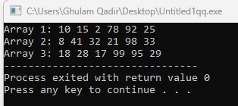

**Q2**

Write a C program that simulates rolling a single die multiple times based on user input. The program

should perform the following tasks:

1. Prompt the user for the number of times they want to roll the die. Validate that the input is a

positive integer.

2. Store the results of each roll in an array.

3. Calculate and display the total sum of all rolls.

4. For each roll, print:

A message indicating whether the roll was:

You rolled a six!

You rolled a one!

High roll!; if the value is 4 or greater.

Low roll. if the value is less than 4.

Hint: Random Number Generate

seed += 4

die = (seed * (i + 1) % 6) + 1

**SOL**

#include <stdio.h>

int main() {

int numRolls;

printf("How many times do you want to roll the die? ");

scanf("%d", &numRolls);

if (numRolls <= 0) {

printf("Please enter a positive integer for the number of rolls.\n");

return 1;

}

int rolls[numRolls];

int die;

int totalSum = 0;

int seed = 1;

for (int i = 0; i < numRolls; i++) {

seed += 3;

die = (seed * (i + 1) % 6) + 1;

rolls[i] = die;

totalSum += rolls[i];

printf("Roll %d: %d -> ", i + 1, rolls[i]);

if (die == 6) {

printf("You rolled a six!\n");

} else if (die == 1) {

printf("You rolled a one!\n");

} else if (die >= 4) {

printf("High roll!\n");

} else {

printf("Low roll.\n");

}

}

printf("Total sum of all rolls: %d\n", totalSum);

return 0;

}

**Output**

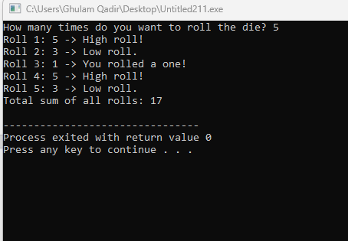

**Q3.**

Create a simple Cafe Management System in C that allows customers to order multiple items, view

a running total, and print a final bill. The system should use a do-while loop to continue taking orders

until the customer chooses to exit. The menu should allow the customer to select items, enter

quantities, and calculate the total cost.

The system should display the following menu:

1. Coffee - $2.50

1. Tea - $2.00

1. Sandwich - $5.50

1. Cake - $3.75

1. Print Bill and Exit

Expected Output:

-------- Bill Summary --------

Total amount to be paid: $X. XX

Thank you for visiting Fast Café

**SOL**

#include <stdio.h>

int main() {

int choice, quantity;

float total = 0.0;

do {

printf("\n--------- Fast Café Menu ---------\n");

printf("1. Coffee - $2.50\n");

printf("2. Tea - $2.00\n");

printf("3. Sandwich - $5.50\n");

printf("4. Cake - $3.75\n");

printf("5. Print Bill and Exit\n");

printf("----------------------------------\n");

printf("Enter your choice (1-5): ");

scanf("%d", &choice);

switch(choice) {

case 1:

printf("Enter quantity of Coffee: ");

scanf("%d", &quantity);

total += 2.50 * quantity;

printf("%d Coffee(s) added to your order. Running total: $%.2f\n", quantity, total);

break;

case 2:

printf("Enter quantity of Tea: ");

scanf("%d", &quantity);

total += 2.00 * quantity;

printf("%d Tea(s) added to your order. Running total: $%.2f\n", quantity, total);

break;

case 3:

printf("Enter quantity of Sandwich: ");

scanf("%d", &quantity);

total += 5.50 * quantity;

printf("%d Sandwich(es) added to your order. Running total: $%.2f\n", quantity, total);

break;

case 4:

printf("Enter quantity of Cake: ");

scanf("%d", &quantity);

total += 3.75 * quantity;

printf("%d Cake(s) added to your order. Running total: $%.2f\n", quantity, total);

break;

case 5:

printf("\n-------- Bill Summary --------\n");

printf("Total amount to be paid: $%.2f\n", total);

printf("Thank you for visiting Fast Café!\n");

break;

default:

printf("Invalid choice. Please select a valid option.\n");

}

} while (choice != 5);

return 0;

}

**Output**

